
Lebanese University
Faculty of Engineering-Branch III
Department of Mechanical Engineering

الجامعة اللبنانية
كلية الهندسة – الفرع الثالث
قسم هندسة الميكانيك

Hawraa Houmani-Individual Contribution Report
Course: Sensors & Instrumentation (Academic Year 2025–2026)
Instructor: Dr. Mohamad Ahmad Aoude
Group Number: C3
Project Title: Smart Greenhouse Monitor and Controller

Contribution Summary
During this three-week project, my primary technical responsibilities focused on hardware schematic illustration, firmware integration, and data processing. I designed and documented the complete system-level circuit software schema using Cirkit Designer. I also took the primary lead on the physical 3-point calibration, data acquisition, and mathematical modeling for the light-dependent resistor (LDR) sensor. Additionally, I was responsible for exporting all raw continuous CSV files and developing the professional multi-sensor performance graphs in Microsoft Excel for every sensor modality featured in our final technical report.

Evidence of Work Performed
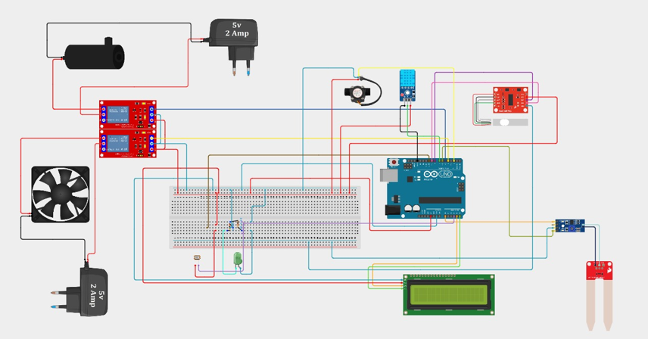
- Complete System Circuit Schematic Design
Designed and drafted the complete system-level wiring schema using cirkit designer

- Excel Data Processing & Graphing Workbook
- Assisted Light Sensor (LDR) 3-Point Calibration Worksheet
Led the physical 3-point experimental calibration for the optical sensor modality. Modeled the mathematical calibration equation, and plotted the final calibration curve to minimize active measurement error.
During the physical testing phases, I monitored the serial stream from the Arduino Uno to log the raw analog-to-digital converter (ADC) values (0 - 1023) at each of the benchmark states:
- Darkness (Raw ADC $≈$ 20)
- Room Light (Raw ADC$≈$ 900)
- Flashlight Saturation (Raw ADC $≈$982)
I recorded these boundaries to help establish the data points needed for the group's piecewise calibration curves.
Because an LDR has inherently non-linear resistance curves, a simple single-line mapping introduces heavy errors in the mid-range. I assisted in dividing the sensor's operating range into a two-segment piecewise linear equation to minimize mapping discrepancies:
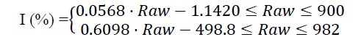

Personal Reflection & Lessons Learned
- Technical Growth & Academic Insights
Participating in this smart greenhouse project provided me with a profound, hands-on understanding of physical instrumentation, data acquisition, and system-level calibration.
Prior to this lab, calibration felt like a purely theoretical exercise. Taking charge of the Light-Dependent Resistor (LDR) calibration showed me the physical realities of sensor behavior. Because LDRs are highly sensitive and inherently non-linear, applying a simple standard scaling calculation would have resulted in massive errors. Manually collecting physical benchmarks (from absolute darkness to full saturation) and dividing the operating range into a two-segment piecewise linear equation bridging experimental data with real-time firmware execution was incredibly rewarding. It taught me how to handle sensor sensitivity and mathematically compensate for systemic measurement errors.
Additionally, working on the system-level circuit schematic forced me to think like a systems engineer. I had to carefully map out the voltage and current limits of the Arduino Uno, ensuring that high-current inductive loads (such as the 12V water pump and the 5V cooling fan) were isolated using opto-couplers and relays so as to not damage our microcontroller.
- Practical Data & Software Skills
Exporting the raw continuous serial output into CSV format and building the master data tables in Microsoft Excel developed my analytical visualization skills. Tracking how different variables interact over time—such as witnessing soil moisture levels rise concurrently with total pot mass as water is pumped in—solidified my understanding of dynamic physical systems and transient behavior. In terms of software control, organizing our GitHub repository taught me the critical importance of clean, modular folder structures (/code, /data, /docs, /report, /video) and version control when working under tight constraints.
- Collaboration & Team Dynamics
On a personal level, this project emphasized the power of multidisciplinary teamwork. Coordinating between hardware designs, software configurations, and mathematical calibrations meant that my teammates and I had to communicate constantly and clearly. Merging our individual efforts into a unified, functional system under a tight deadline was challenging but deeply rewarding. This experience has significantly built my confidence in troubleshooting complex, multi-component engineering systems and highlighted how vital structured documentation is to the success of any engineering project.

